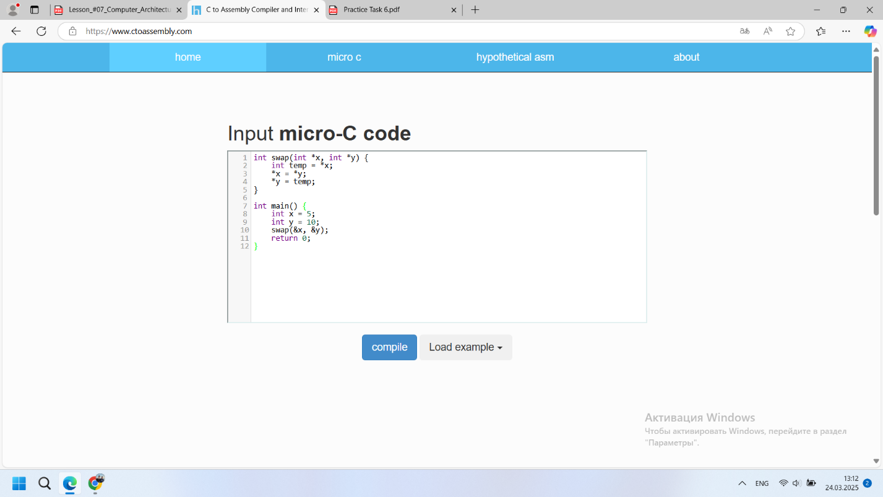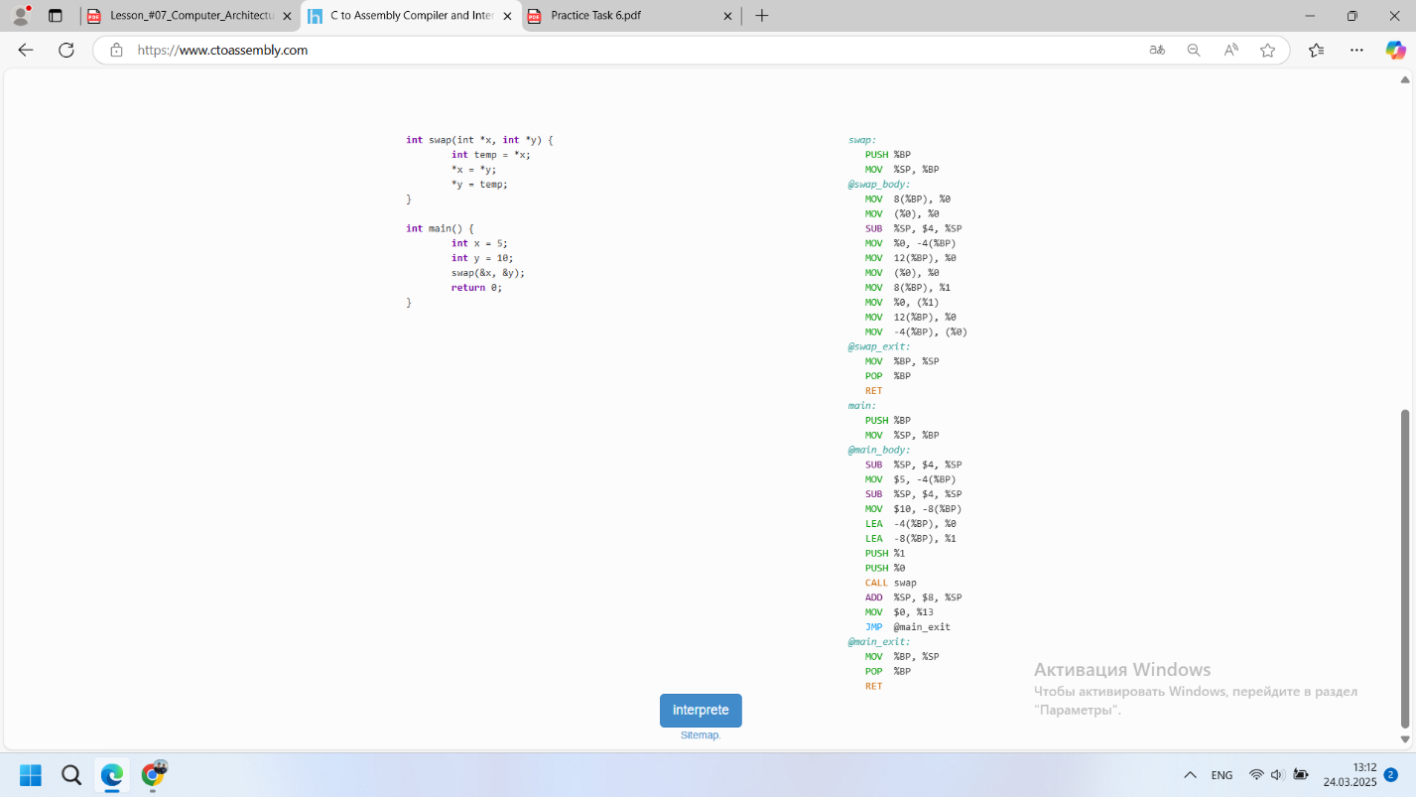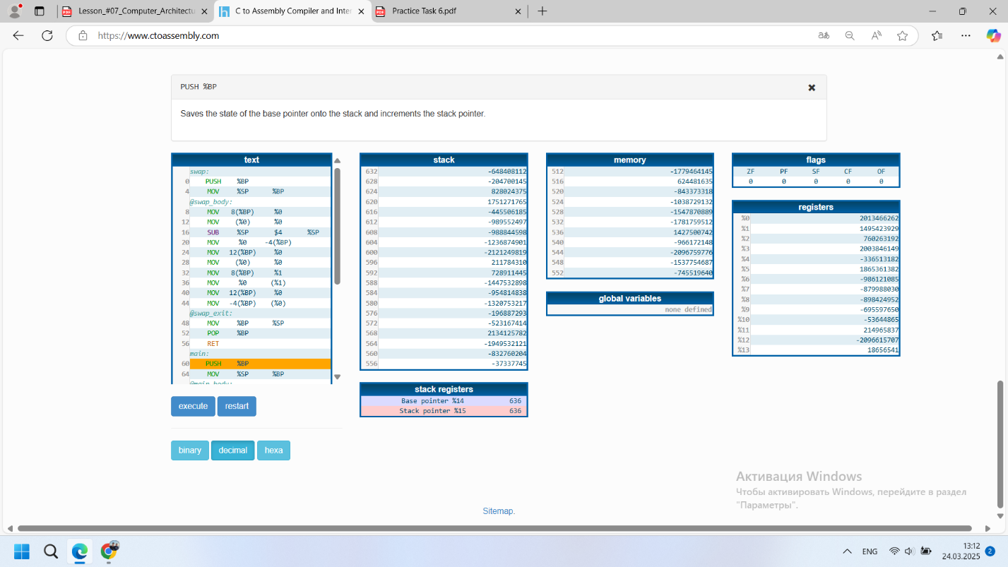

Assembly code:  
main:  
First, space is allocated on the stack for variables x and y. Then, the addresses of x and y are taken and passed to the swap function.  
swap:  
First, the old value of x is saved in a temporary variable. Then, the value of y is written into x. Finally, the value of temp is written into y.

Memory:  
Stack:  
The stack stores local variables x and y, as well as temporary data.  
The addresses of the variables are passed to the swap function so that it can modify their values.

Registers:  
eax, edx, rsi, rdi are used to store intermediate values and addresses.  
For example, eax temporarily stores the value of x, while rdi and rsi pass the addresses of x and y to the swap function.